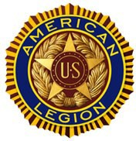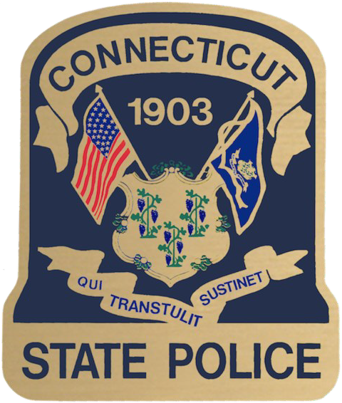State Police

Youth Week



## The American Legion Department of Connecticut

***The American Legion***

***Department of Connecticut***

|  |  |
| --- | --- |
|  |  |
| **What do they think of it?**  **Graduates write:**  **“They taught us discipline and to work together as a team, so that we could achieve our**  **goals. The desire to**  **accomplish and succeed was always there.”**  **“Thanks to the American**  **Legion and to all the Troopers**  **who participated in State Police Youth Week. I had a**  **great time and learned a lot. It was a great experience.”**  **“I would like to thank all of the Troopers who volunteered their time and energy in giving me the experience of a lifetime.”**  **“I wasn’t really thinking of**  **joining the police before this.**  **Now, I think that law**  **enforcement is the direction I am heading. I truly hope that the cadets in the next State Police Youth Week get as**  **much out of it as I did.”** |
| **Connecticut State Police** |

**864 Wethersfield Ave**

**Hartford, CT 06114**

**860-296-0719**

**July 27 to August 2, 2025**

***Sponsored by***

# The American Legion Department of Connecticut

***and***

# The Connecticut State Police



***The Program***

**Connecticut State Troopers**

**The American Legion Connecticut State Police Youth Week is designed to provide an insight into the training and professional expectations of a police officer. The program is mentally and physically demanding, patterned after recruit training at the State Police Training Academy. It offers an excellent opportunity for students considering a career in law enforcement to gain first-hand knowledge of the training and duties of a police officer. The program is NOT a recreational camp, nor a disciplinary camp for problem youths. Students must be recommended for the program, be in good academic standing, and physically fit. Training is conducted in a paramilitary atmosphere, fostering a positive attitude among the cadets and enabling them to achieve goals they may have imagined as unattainable.**

**A TYPICAL DAY**

**Cadets awake early, prepare quarters for inspection and participate in physical training. They march in formation to all scheduled classes and activities. Cadets attend instruction in subjects such as: Connecticut Penal and Motor Vehicle Codes, police radar use, firearms safety and familiarization, tactical operations, motor vehicle operation, self-defense, employment of trained dogs as well as other police skills. The program is conducted at the Connecticut Police Academy, 285 Preston Road, Meriden, CT. Participation in the program is STRICTLY LIMITED.**

## COURSE INFORMATION

### STAFF

The Connecticut State Police provide personnel from the staff of the State Police Academy and community trust liaisons who serve as Training/Activities Director, Curriculum Director, and Staff Instructors. The Program Director is a member of the American Legion. Counselors and medical personnel are members of the State Police Academy staff. Instructors are drawn from various components of the law enforcement community and have previously included instructors from the Judicial Department, the Department of Criminal Justice and the Office of the Chief Medical Examiner.

### EQUIPMENT

Cadets are issued an official cap, t-shirts, trousers and belt to be worn during training (except recreational periods). Each student must furnish additional equipment: white sneakers, white athletic socks, khaki pants personal toilet articles, towels, clothing for athletic activities, swimwear (female-one piece tank-type) and athletic shorts. Detailed equipment requirements will be provided in the Letter of Acceptance to the program. Washers and dryers are available at the Academy.

### GRADUATION

**Graduation exercises will be held at the Connecticut State Police Training Academy on Saturday, August 2nd, 2025. Details will be provided in acceptance letter.**

### REGISTRATION AND CHECKOUT

Registration will be held on Sunday, June 27, 2025. Specific reporting time to be provided in the Letter of Acceptance to the program. Checkout will commence immediately after graduation on Saturday, August 2, 2025. Individuals providing transportation will be permitted to pick up cadets at the Training Academy ONLY. NO EXCEPTIONS will be made.

### SPONSORSHIP

Cadets (male or female) may be sponsored by an American Legion Post, District, Auxiliary Unit or Civic Group (i.e. FOP, Rotary, Lions, Elks, etc.). Sponsors are responsible for attendance of the cadet, payment of tuition, and transport to and from the Academy.

### SELECTION

Applicants must have completed Junior Year (11th Grade) prior to attendance. Post or District Commanders may interview and nominate applicants. Nominees must be in good health and academic standing. Applicants must desire to attend the program. Selection for attendance will be made by a joint committee of The American Legion and State Police Academy cadre.

### MEDICAL EXAMINATION / INSURANCE

A medical examination performed within ten months of attendance, a signed Waiver and Indemnification and a consent to Medical Treatment and Hospital Services must be executed prior to attendance. Parents/Guardians are responsible for treatment and disclosure of pre-existing conditions and are required to provide insurance coverage for required care.

**APPLICATIONS MUST BE RECEIVED BY FRIDAY, JUNE 6, 2025,**

in order to allow sufficient time for selection and notification. Applications must be signed by the Commander/President of the sponsoring organization (if applicable) and must be submitted with all supporting documentation (Photograph, Personal Statement and Recommendation). Applications must be accompanied by a NON-REFUNDABLE fee payment check in the amount of $125.00, payable to The American Legion Department of Connecticut. Payment received for those not selected for attendance will be refunded.

